# **Installation and website navigation guide for The Clechuderfax E-chain**

## Installing and copying required programs and setting up workspace

* Download and install XAMPP latest version and enable oci8_12c, pdo_oci php extensions to connect Oracle and php.

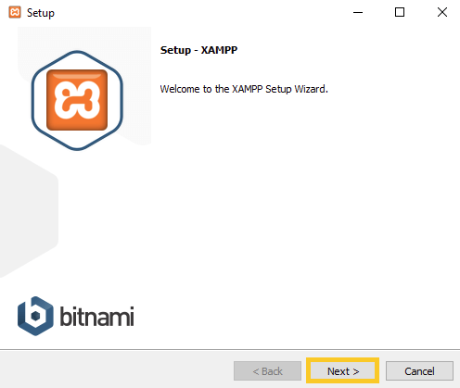

* Download and install Oracle Database XE 11g on your system.

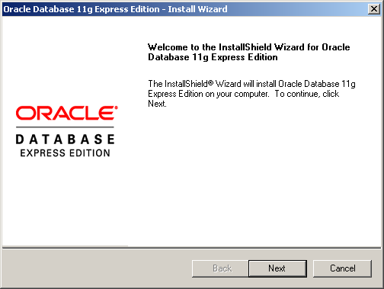

* Download Oracle Instant Client for your machine, extract it and set the environment variable.

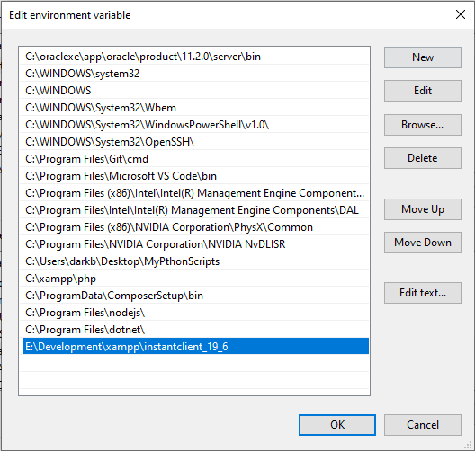

* Download Oracle 19.2_en.zip and upgrade Oracle 11g XE to Oracle 19.2c using SQL plus.
* Start XAMPP and start Apache server by clicking on the start button on the first row.

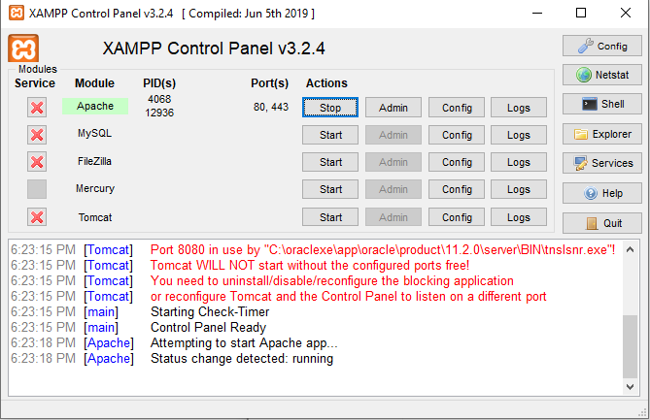

* Open your browser and go to <http://localhost:8080/apex/apex_admin>
* Login using the admin username and password that you created while upgrading Oracle.
* Create a new Workspace give it a name of The Clechuderfax E-chain and click next.

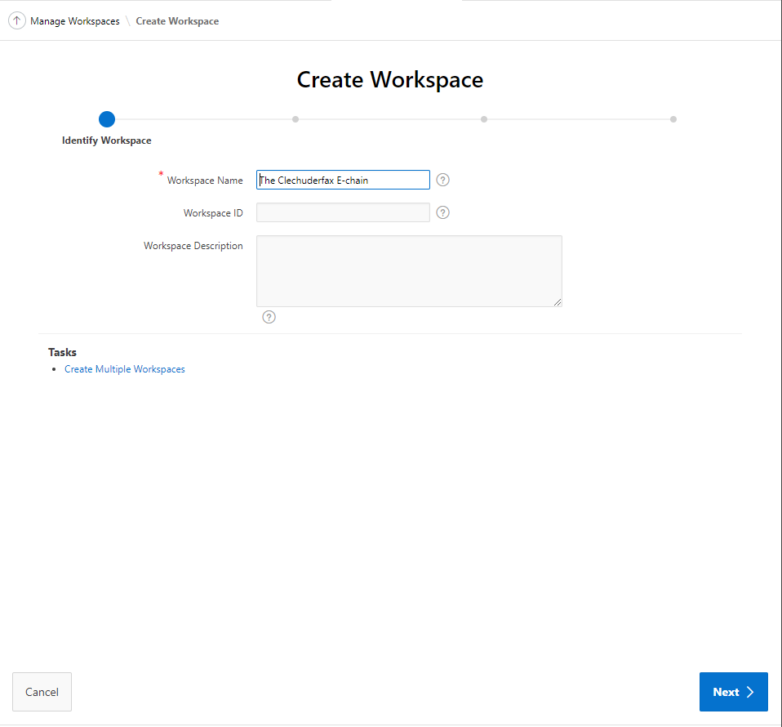

* Select Yes from Re-use existing schema dropdown and select HR in Schema Name and click next.

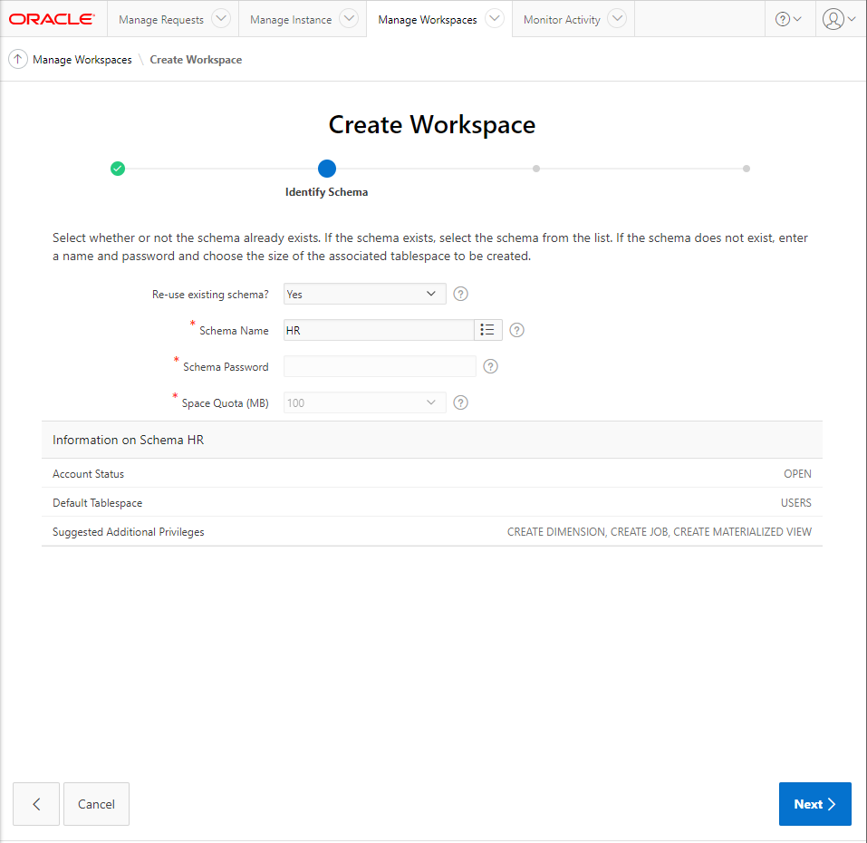

* Enter an administrator Username and password and also enter the email and click next.

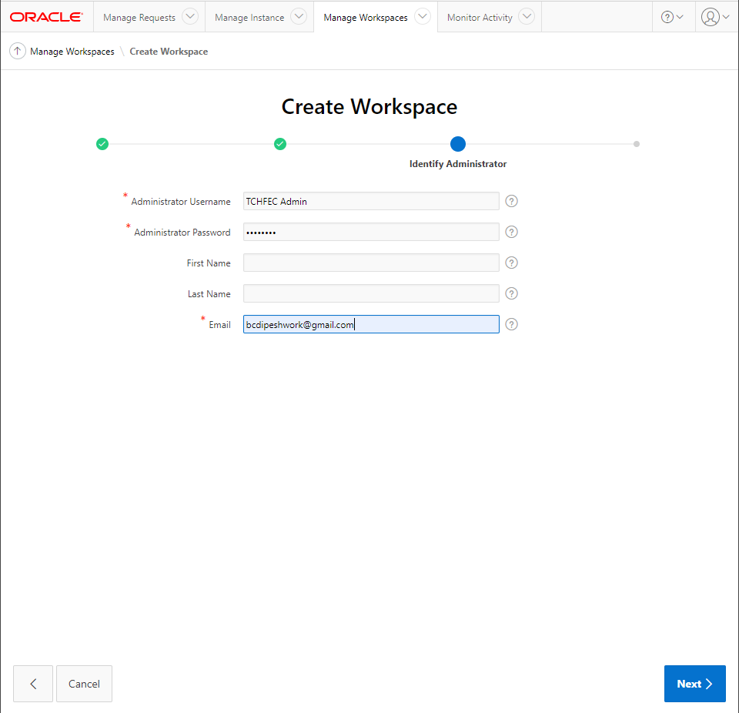

* Finally, click on create workspace button to create your workspace.

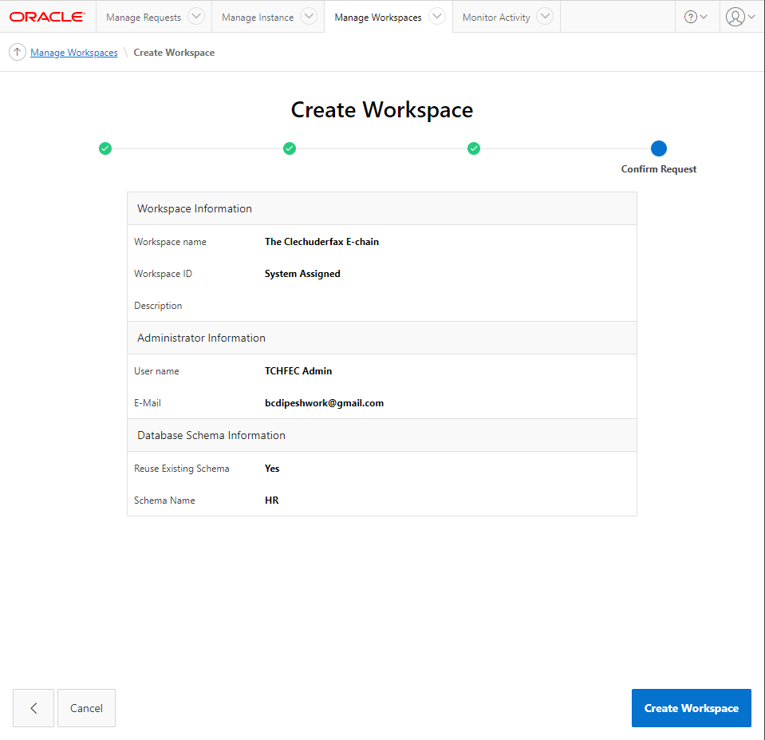

* Sign out from the admin page and return to sign in page and login with your newly created workspace login details.
* Click on the SQL workshop button and navigate to SQL scripts page.
* Upload script files for table, sequence and trigger generation along with table data and run each script file.

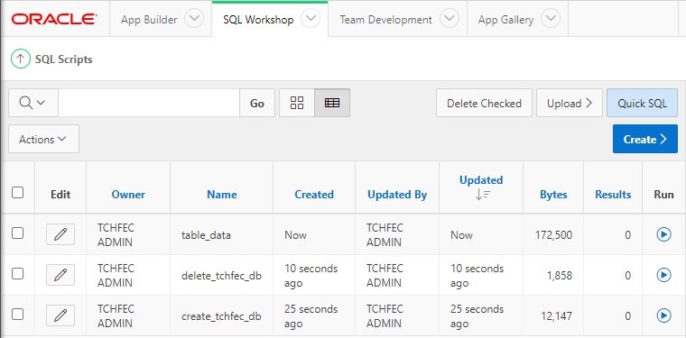

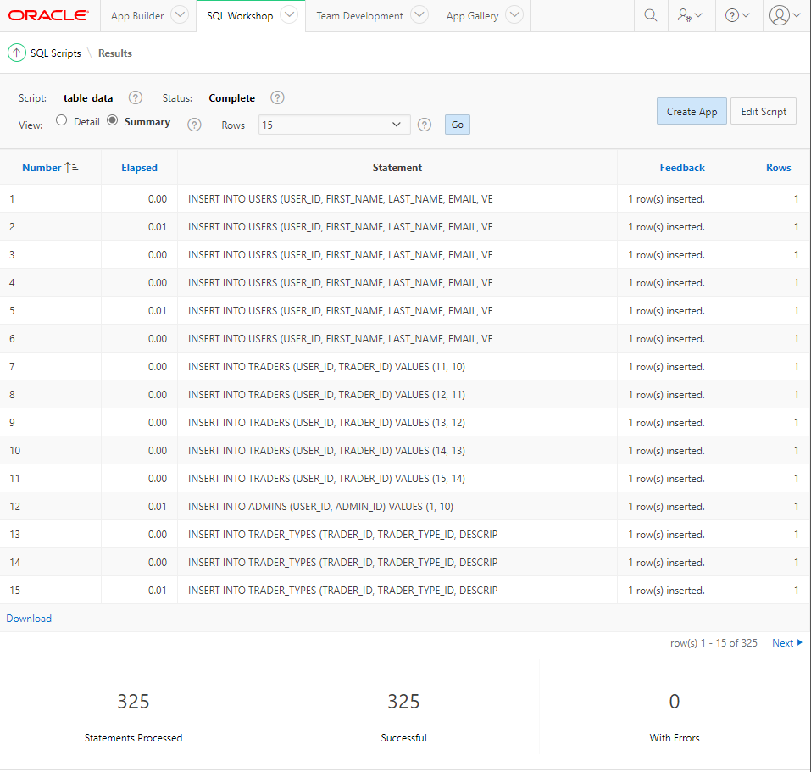

* Copy the included Website folder to htdocs folder present inside the directory you installed XAMPP.
* Rename the Website folder to the-clechuderfax-e-chain.

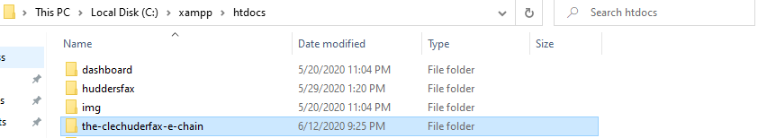

* Now to use the website open up your browser and go to <http://localhost/the-clechuderfax-e-chain/> (**make sure your Apache server is running inside XAMPP**).

## **Customer User Guide**

* To register/login a customer clicks on the hamburger menu on the top-right corner of your browser.
* Customers can register if they are not registered through Customer Sign up link.

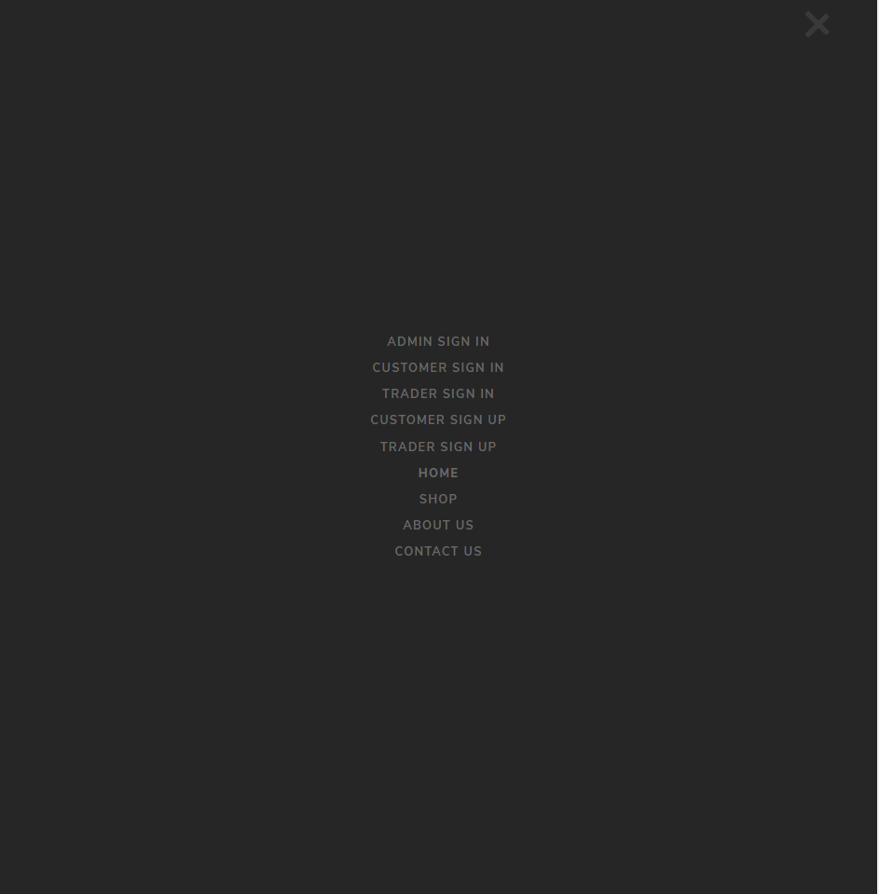

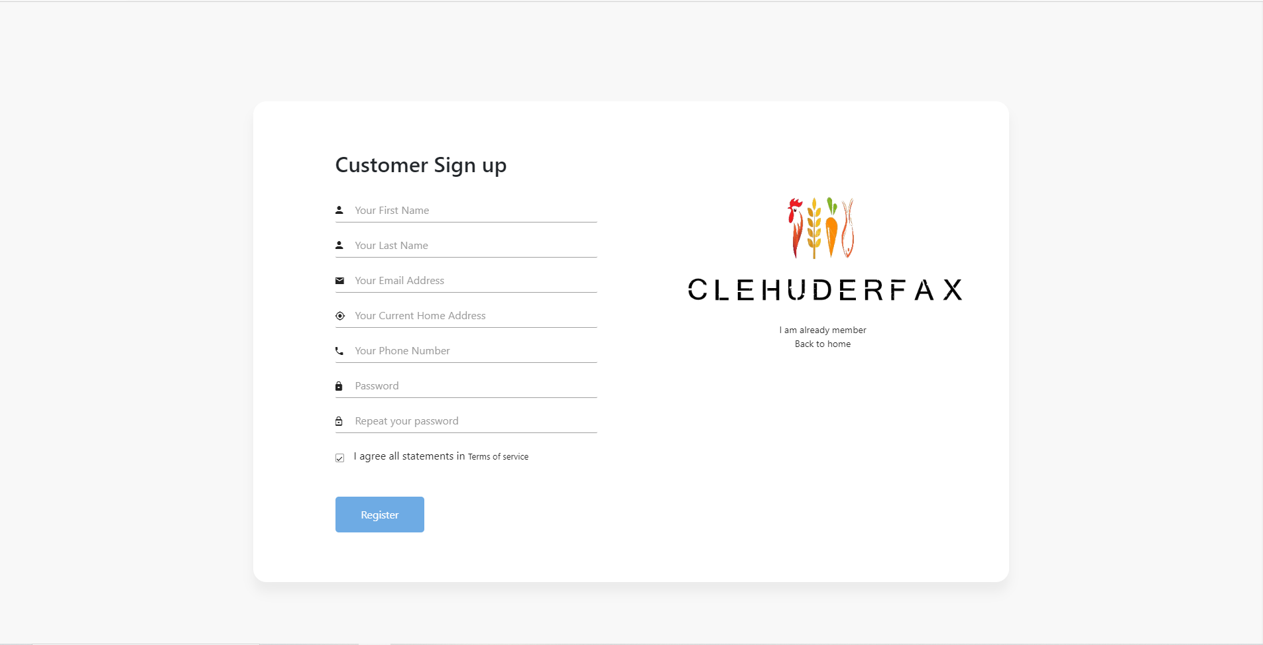

* User will get a email for email verification.

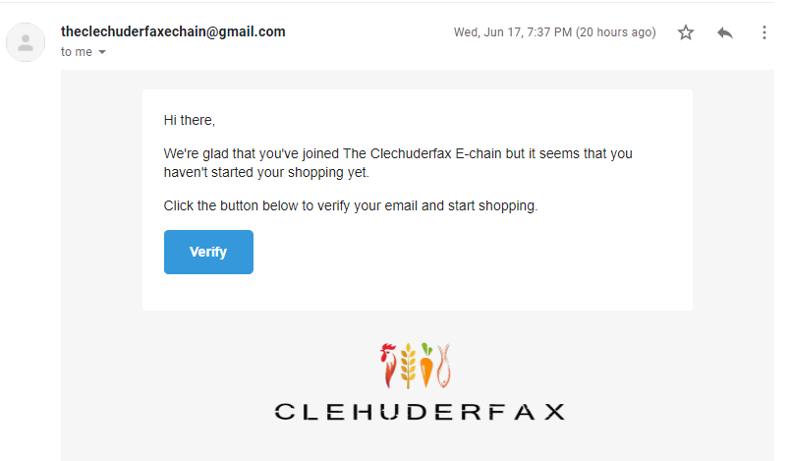

* After registration customer will be redirected to the login page or can go to the login page from Customer Sign in link present in the hamburger menu.

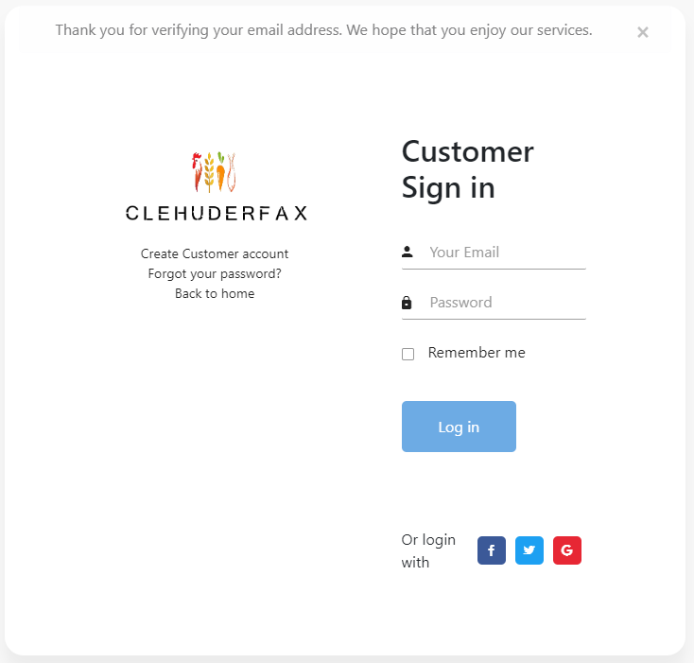

* user can browse search specific products through search bar in home page.



* user can also navigate the products according to category.

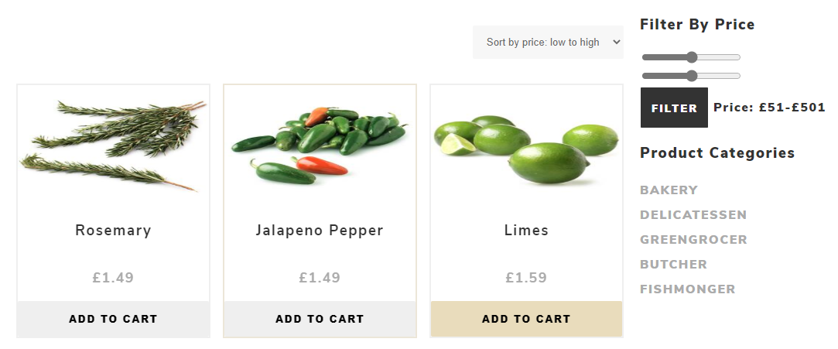

* Logged in user will be able to add products to their cart while non-registered or logged out user will be prompted to login first before adding items to cart.

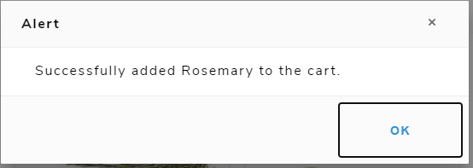

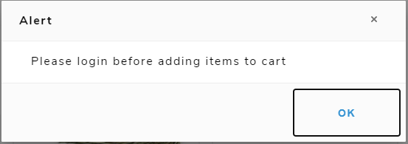

* After adding items to cart user can now go to cart page or product details page to increase or decrease the product quantity.



* Now user can checkout and pay through PayPal.

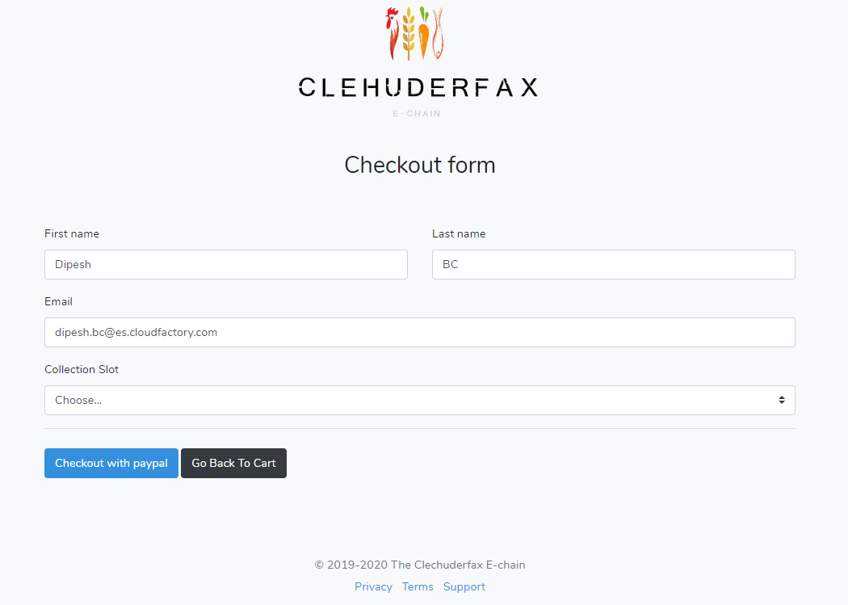

* Use email [sb-ohlya1945761@personal.example.com](mailto:sb-ohlya1945761@personal.example.com) and password PqgMJ0X@ for buying the product.

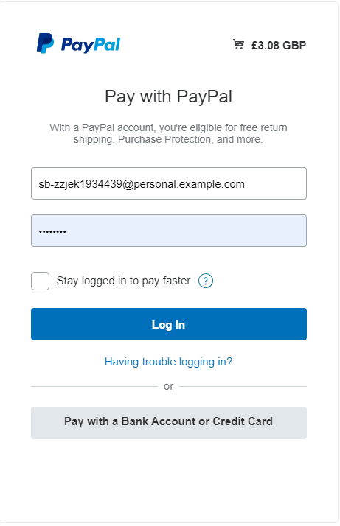

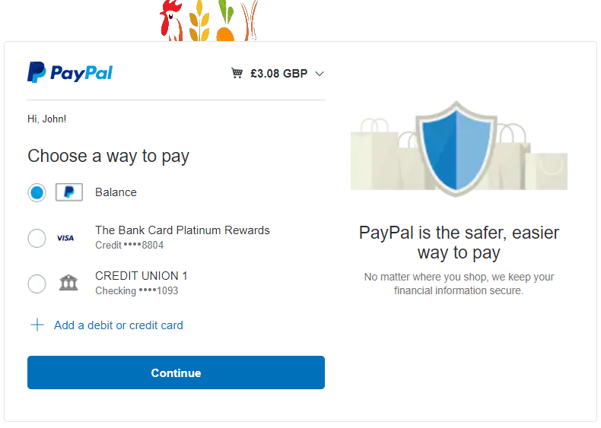

* After Payment user will be redirect to their dashboard where they can see their number of orders in the current month and cart history. Also, a payment invoice will be sent to the user email.

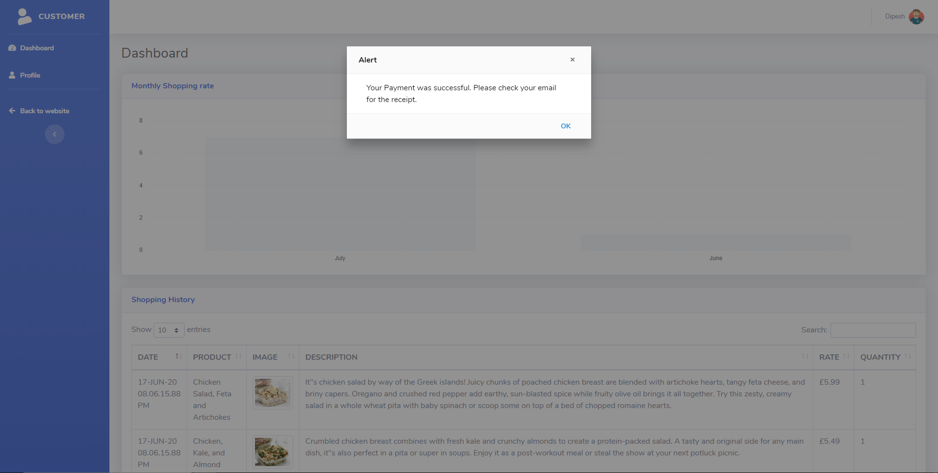

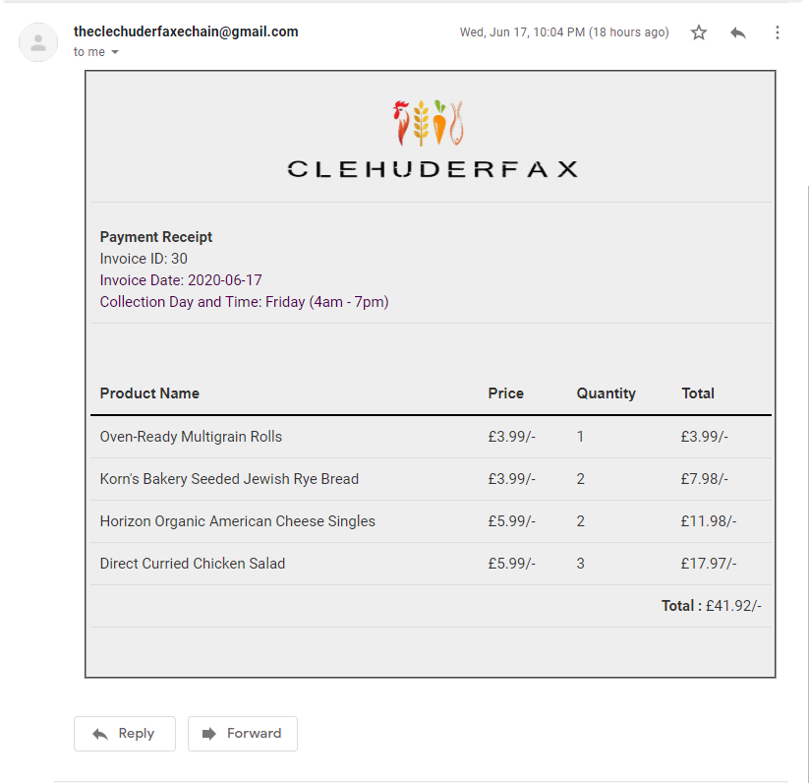

* User can search product by product name.



* User can reset their password with help of Password reset request form.

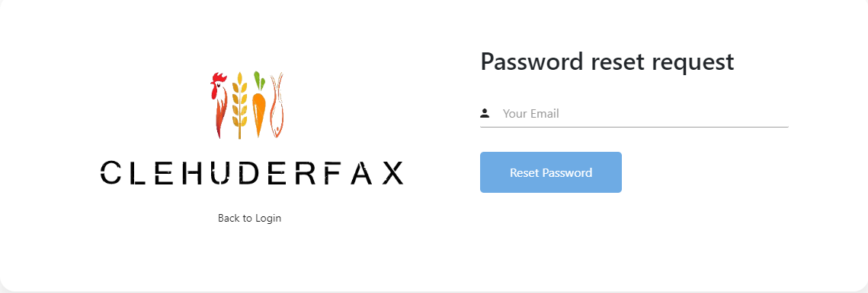

* After submitting password reset request users can check their email to reset their password.

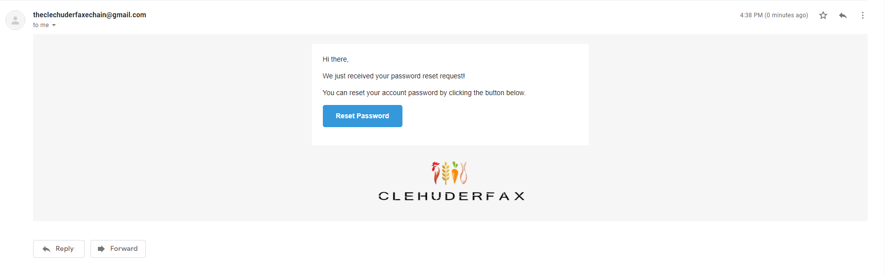

* User can change their profile picture and some details.

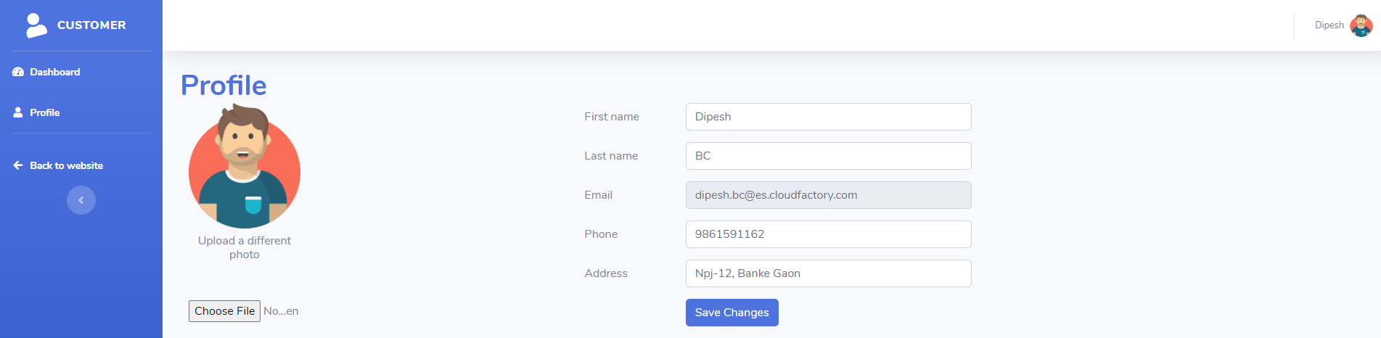

* User can logout through hamburger menu or by clicking on the profile image and selecting logout.

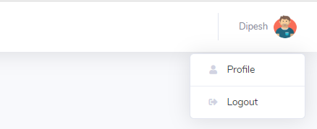

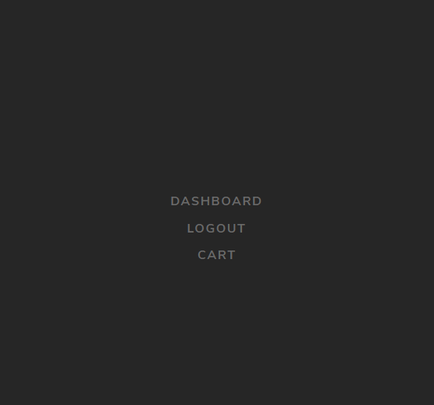

## **Trader User Guide**

* Trader can sign up through the trader’s signup link in the hamburger menu

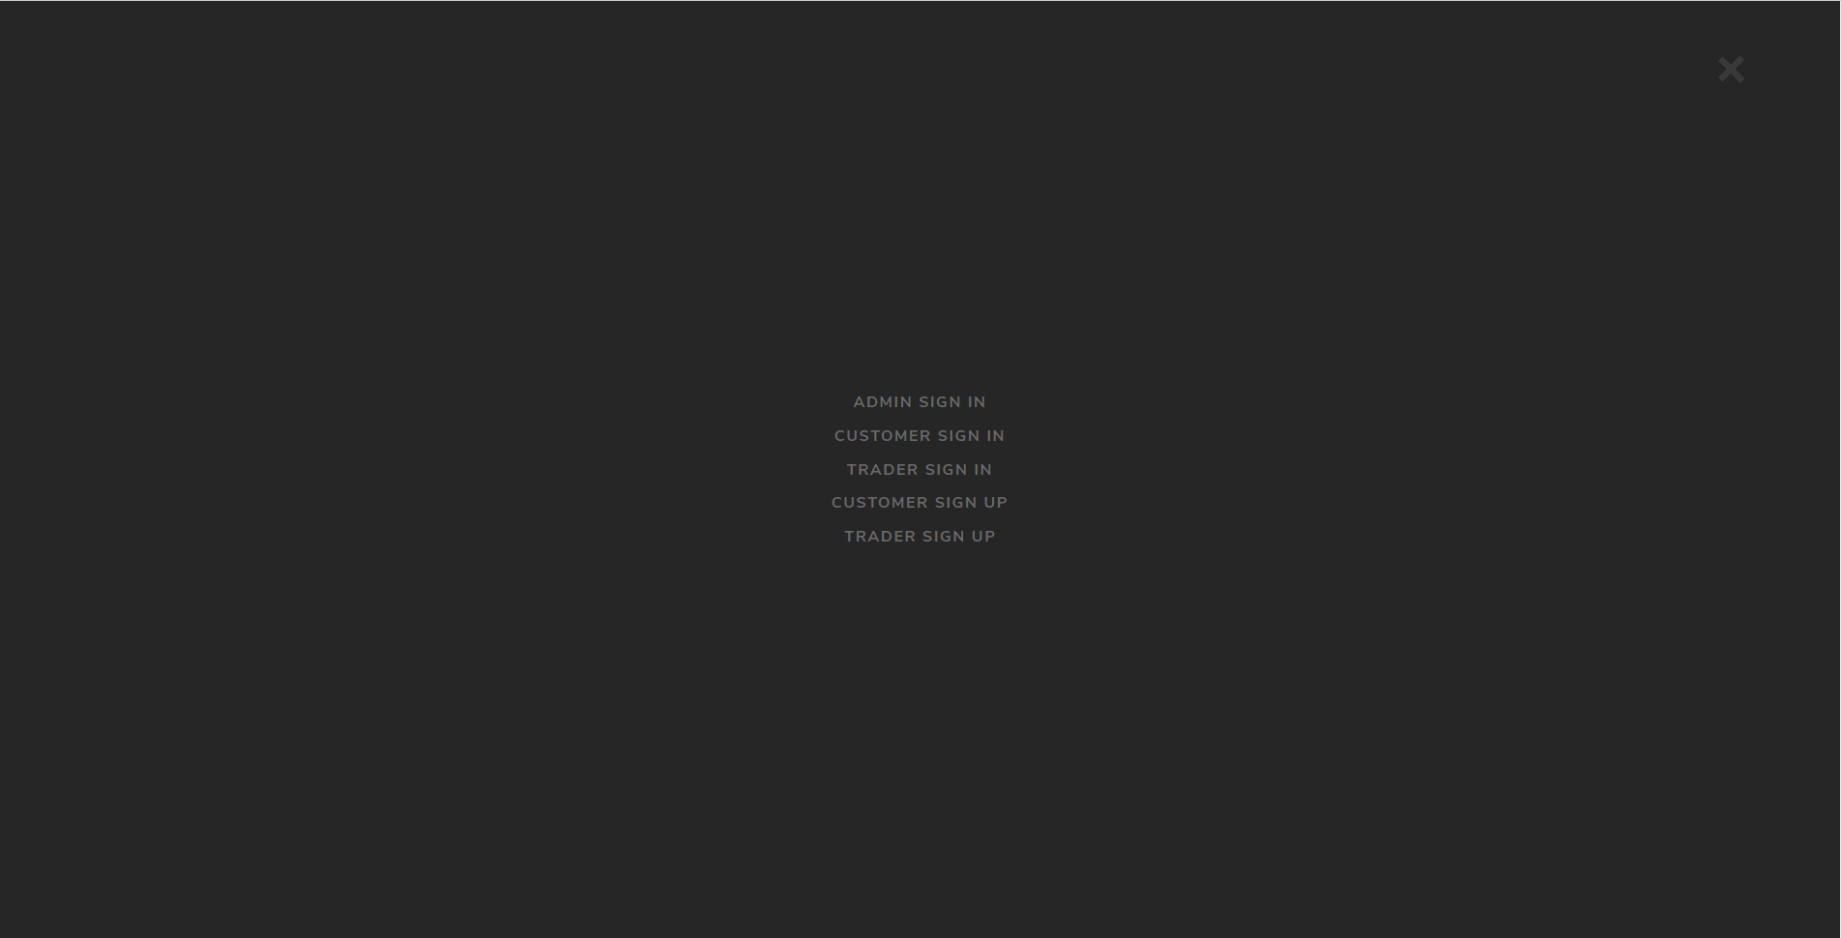

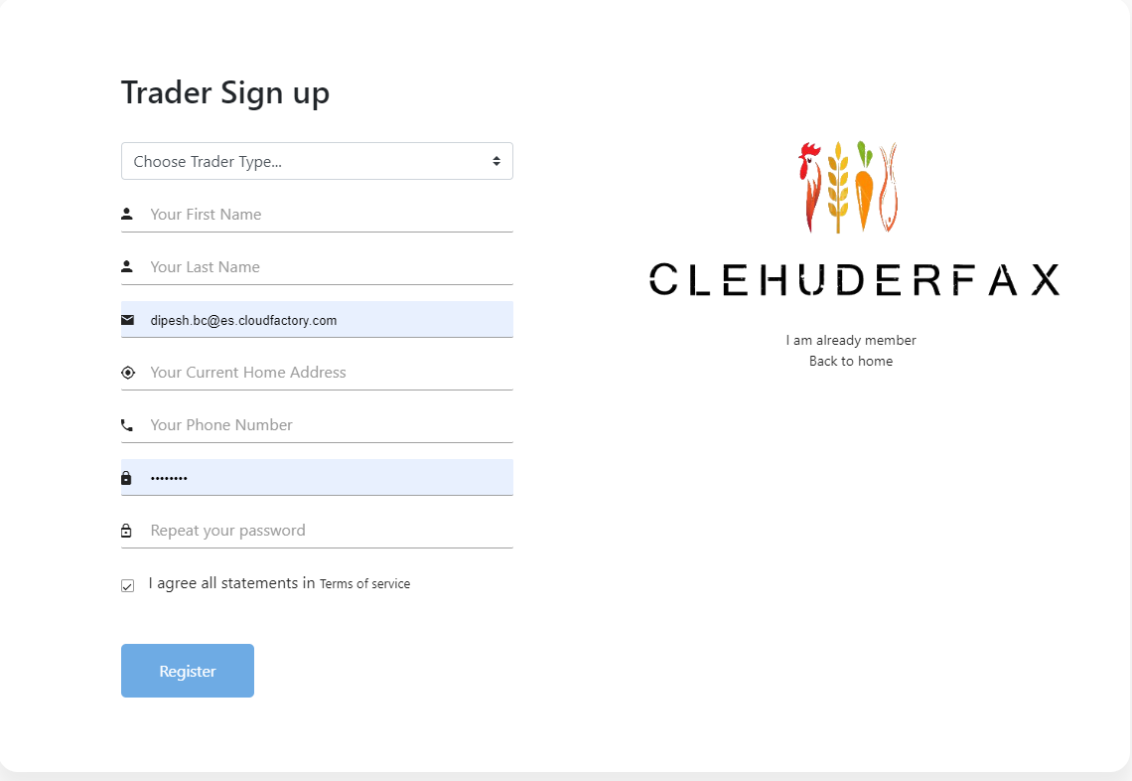

* Trader will get a mail to verify their email.

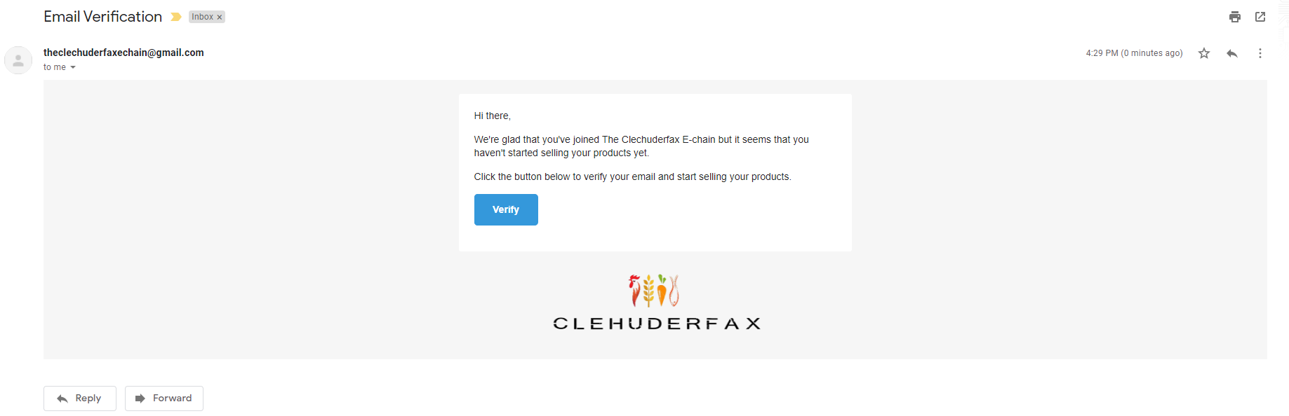

* After successfully signed up traders will be redirected to sign in page.
* Trader can sign in through the trader sign in page.

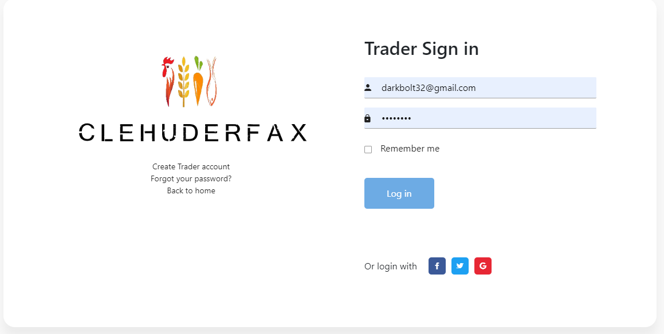

* Traders can reset their password through forgot your password link.

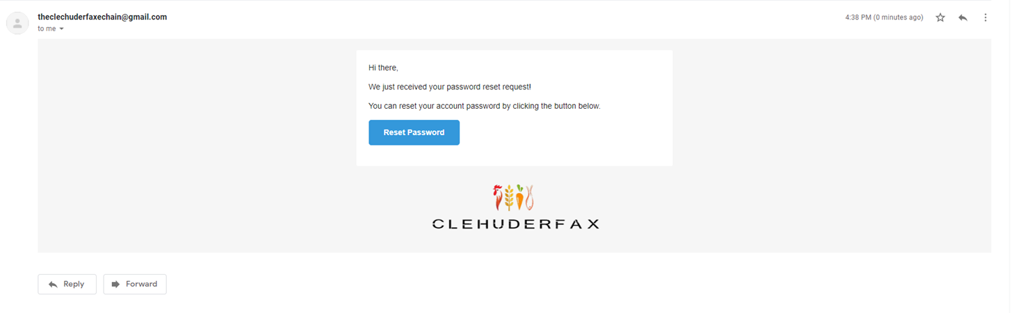

* Trader can view their products, add/update/delete products and their monthly orders.

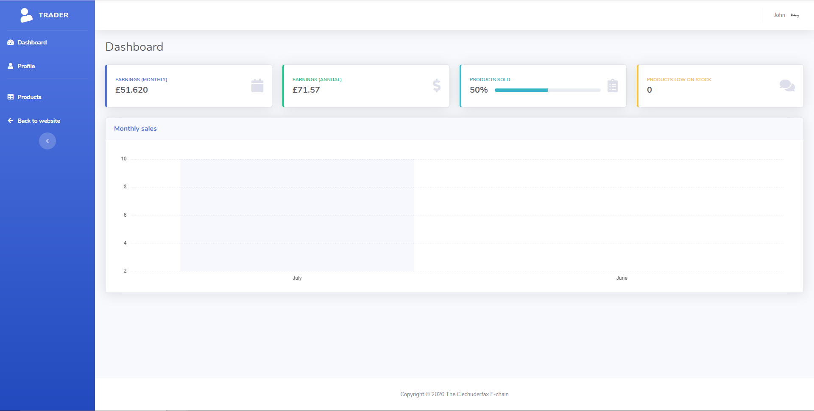

* Trader can view, add and upload products through side bar.

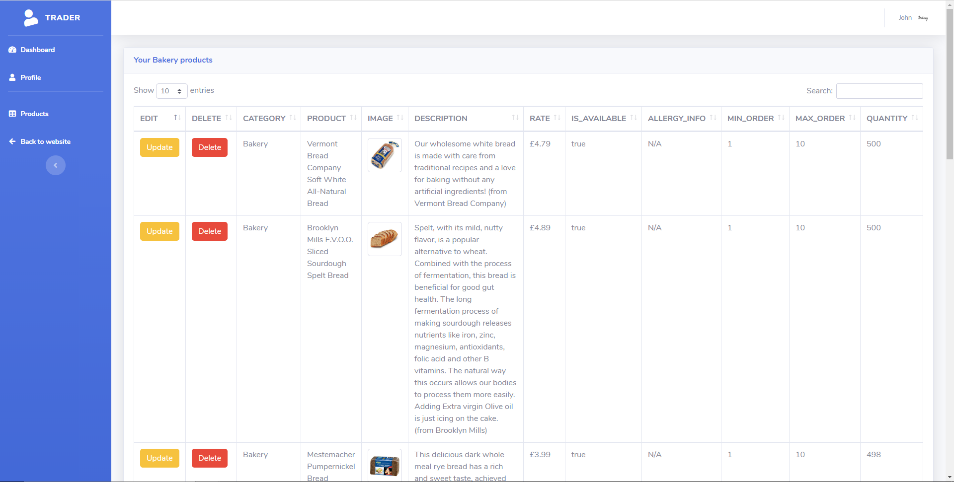

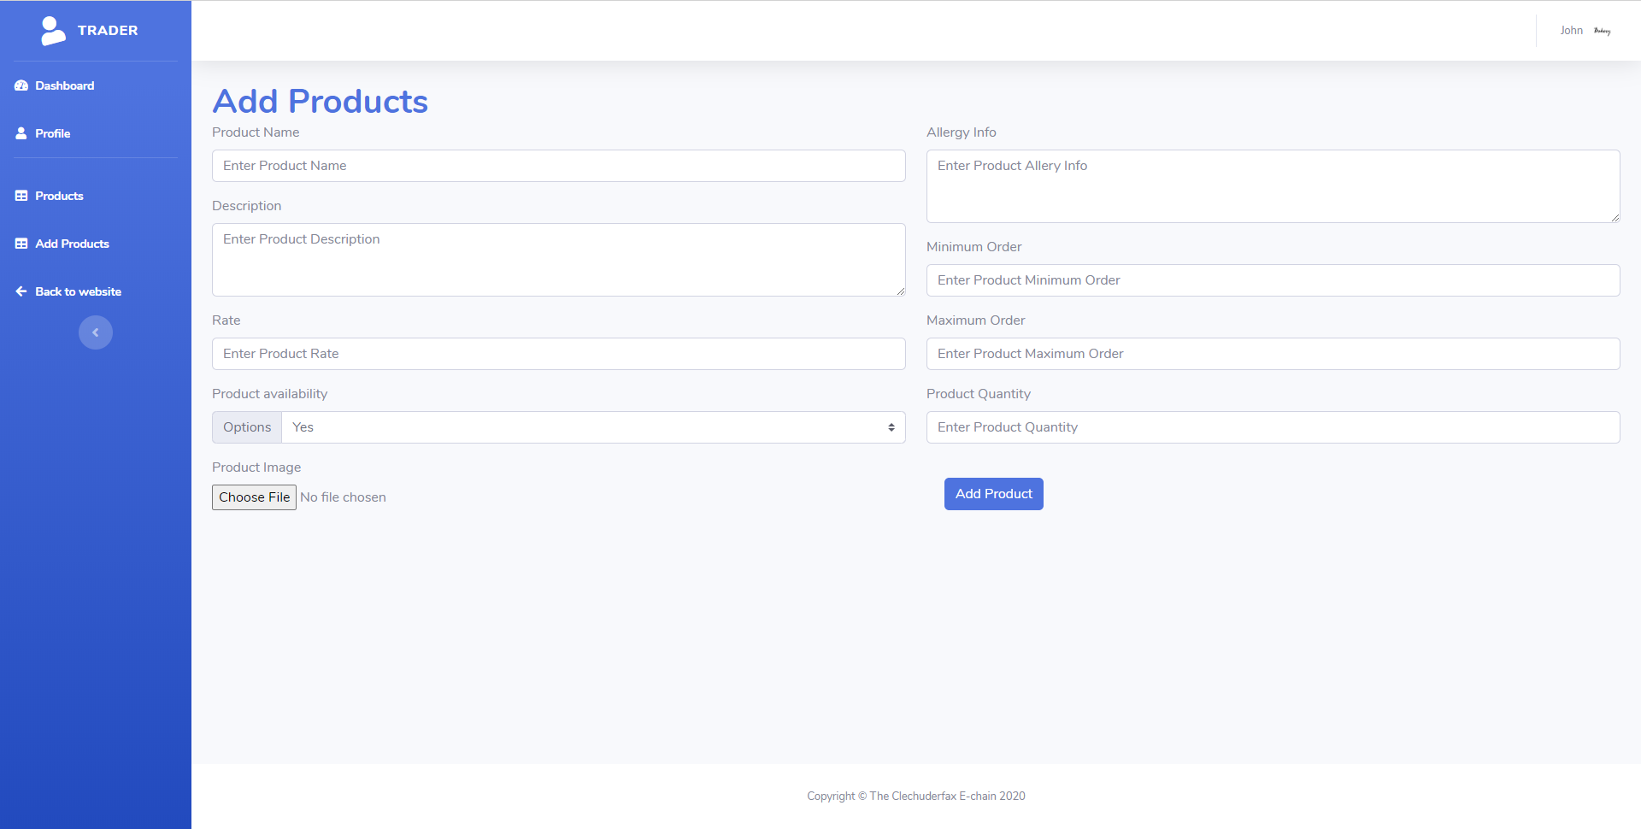

* Trader can logout through two ways in the dashboard.

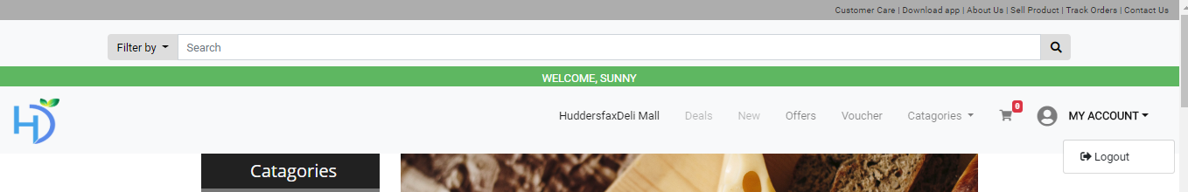

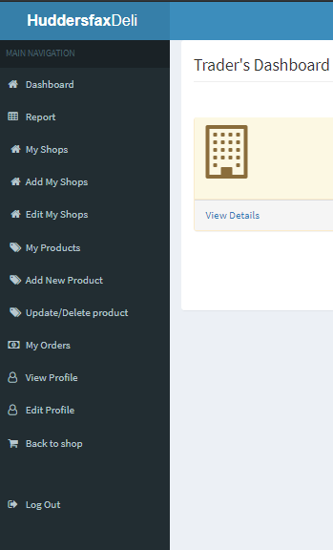

* Trader can view users, review, and products and as well as reports.

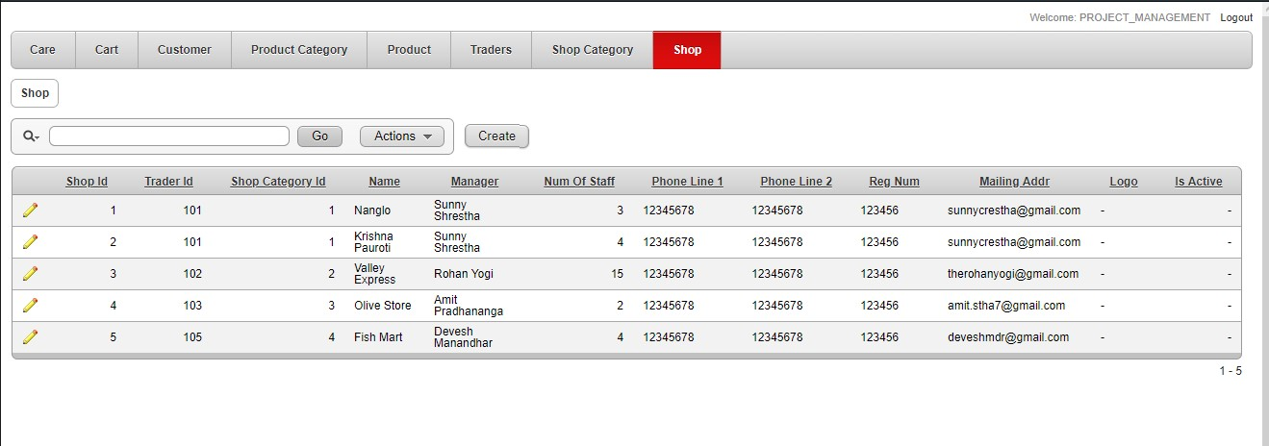

## **Admin**

* Admin can sign in through login page from oracle login address.

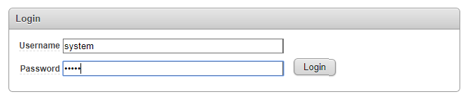

* Admin panel have dashboard through which admin can control traders and customers.

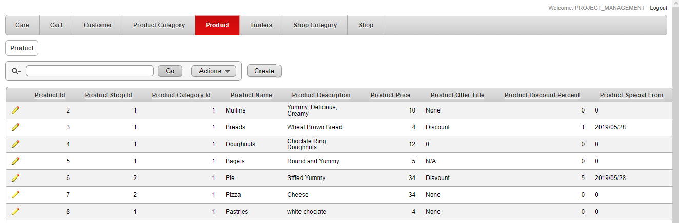

* New traders can be activated through traders and shop tab.

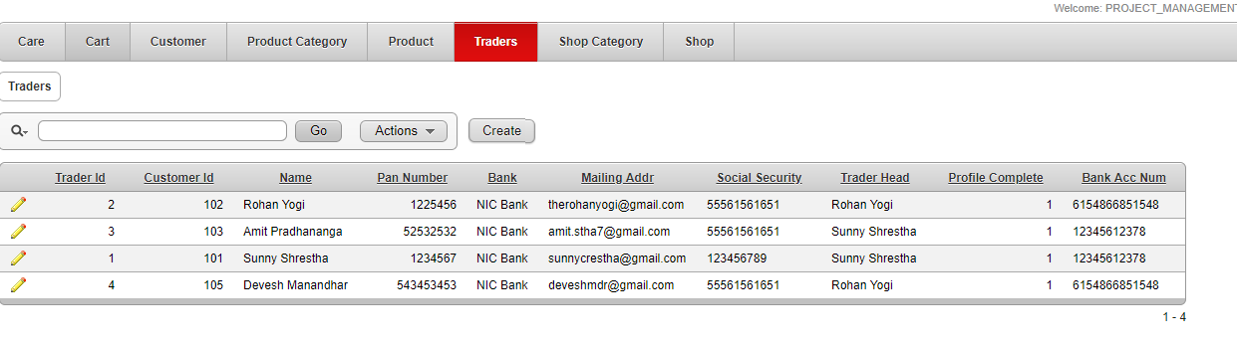

* Admin needs to click the edit image to change the status of traders.

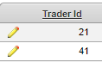

* Admin can change status by changing the status 0.



* Admin can see shops by clicking shops tab.

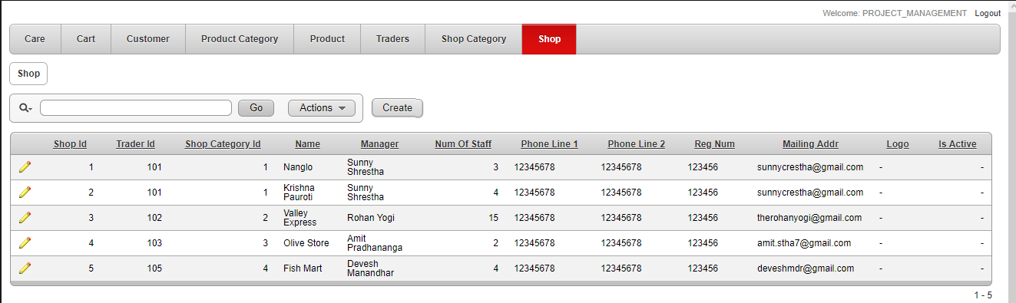

* Admin can update trader’s details by clicking on edit button.

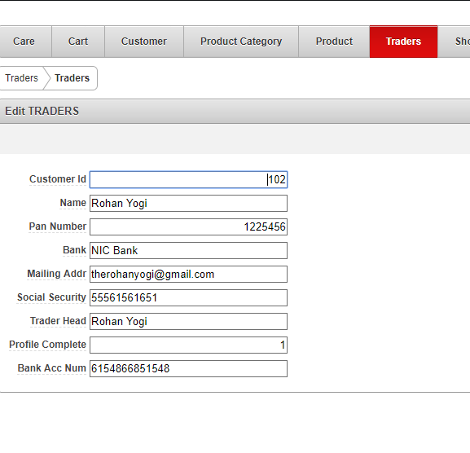

* Admin can see calendar.

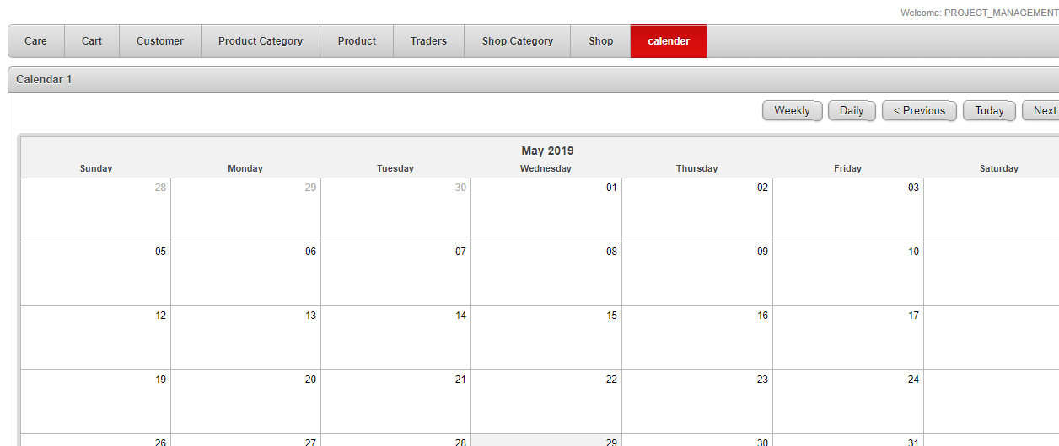

* Admin can view the Products of all the traders.

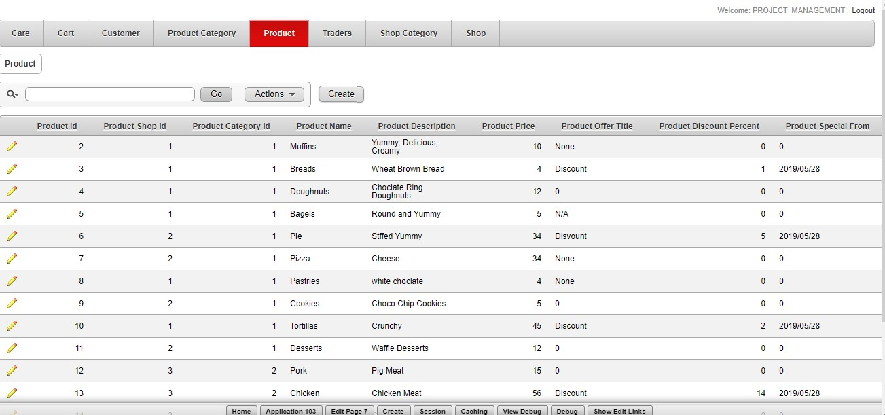

* Admin can edit the products kept by traders.

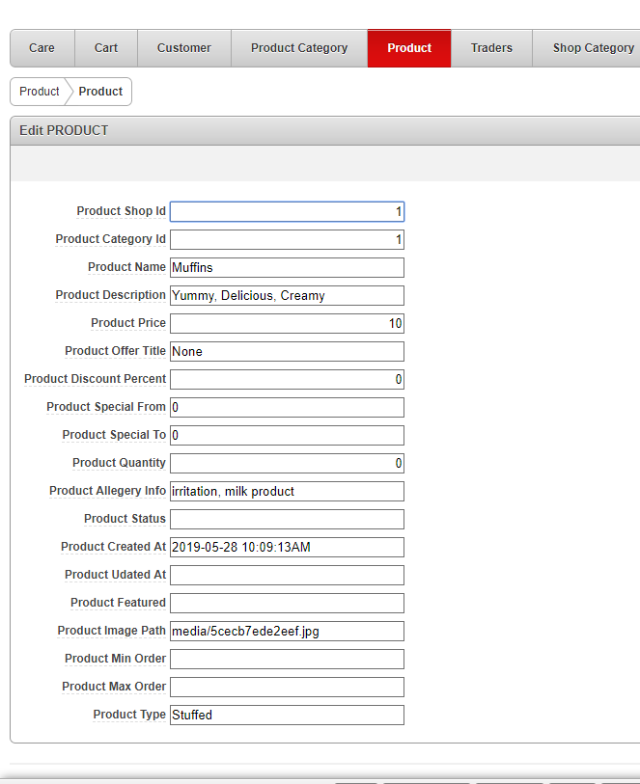

* Admin can view the reviews and cart list from customer.

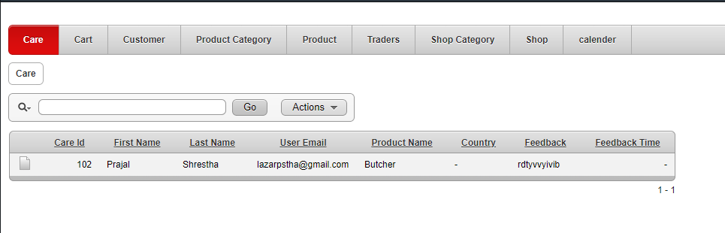

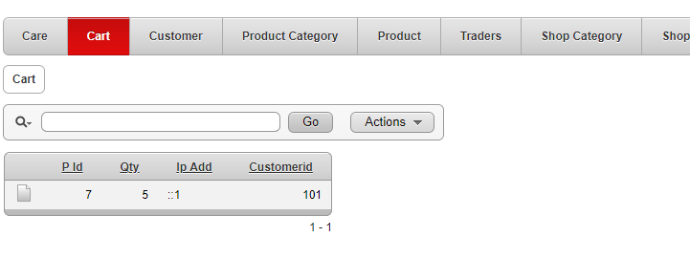

* Setting Up mail:

